Pocono Greyhound Adoption’s
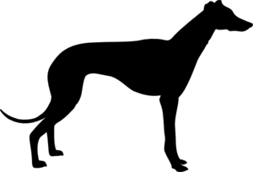
Greyt Hound Hustle
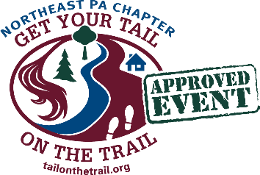
5K Walk/Run & Dog Walk
Sunday September 22, 2019
In Memory of Jakey

All proceeds go to support retired racing greyhounds as they await their forever homes!
Course is a scenic paved and trail 5K. We encourage the walking all leashed dog breeds.
NEW LOCATION:
Beltzville State Park (2950 Pohopoco Dr. Lehighton, PA 18235)
Registration @ 9 a.m.
5K starts @ 10:00 a.m.
- Pre-registration: $20 – Includes a t-shirt if registered by Sept 14th
- Late or Same Day-registration: $25 – Limited number of t-shirts after Sept 14th
***All participants entered in a raffle after the race!!!***
Age Divisions: 1–19, 20-29, 30-39, 40-49, 50-59, 60+; medals run 3 deep in each division

For more information visit: www.poconogreyhound.com or email Alissa at Runner@poconogreyhound.com
ONLINE REGISTRATION at www.active.com and www.racersignup.com
MAIL IN REGISTRATION: Send to Greyt Hound Hustle at 425 North 5th Street, Lehighton PA 18235 Make Checks Payable to Pocono Greyhound Adoption
------------------------------------------------------------------------------------------------------------------
Name: ____________________________________________ Gender: _________ Age: _______
Street: ________________________________________________ City: _______________
Phone Number: __________________ Email: ________________________________________
Indicate T-shirt Size: □Small □Medium □Large □Extra Large Waiver: In signing this entry I, for myself, my heirs, executors, and administrators release PGA and all of its representatives, sponsors, and Beltville State Park, from any and all injuries, damages and/or claims of description which might arise from this event. I have read and understand the aforementioned release and sign it voluntarily. I attest that I am fit, able, and capable of running this race.
Signature ____________________________________ Date ________________
This year we are also adding a FASTEST TEAM DIVISION. Teams can be between 5-7 participants and will be scored cross country style. Each team member should register independently however the list below should be completed and mailed in. Team participants are also able to win individual awards.
TEAM NAME:_____________________________________
Team Member Names: _____________________________________________________
______________________________________________________________________
What makes the Greyhound race unique?
- We encourage you to bring your dog!
- The overall awards are plush greyhounds!
- Free raffle of gift cards and baskets for all participants
- Prizes for finding a plush greyhound hidden throughout the course
- You get to meet LOTS of Greyhounds!!!

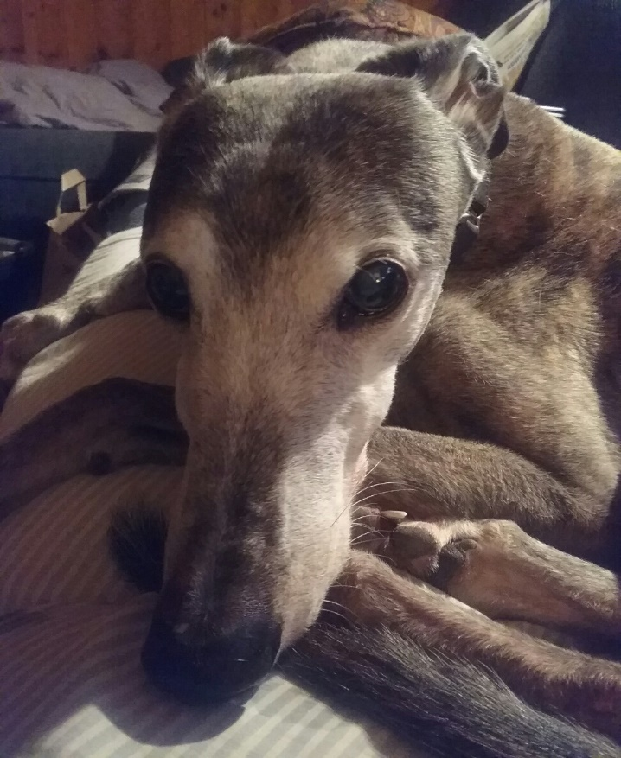
In Memory of Jakey Dec 18, 2002 – Aug 22, 2017
Shorty after we volunteered to help with the GUR's to bring new greyhounds up from Florida we were asked to pick up one boy late one night down in Harrisburg. We went down and met the previous driver at a McDonald's about midnight. It was too late to take him to his fosters, the Ewings, so we kept him overnight. The next morning I told Kim that if we ever got a second greyhound I wanted it to have the same personality as M's Wildfire. After two bounces Wildfire came back to the group. We brought him home to see how he would be with Zoe and he fit right in.
I noticed he walked with a distinctive sway that reminded me of a farmer so he was called Jakey. He was our bug chaser. He helped us with over 80 fosters over the 10 and a half years he was with us and also helped with the scores of greyhounds that stopped here on their way to their foster homes. Jakey and I would have conversations as we were watching TV. He would start and I would answer, some of them quite lengthy.
During a short walk to the mailbox he fell. We took him to the emergency vet where it was determined he had a spiral fracture of the left front leg due to osteosarcoma. We had to make the difficult decision to help him to the rainbow bridge where I’m sure he was met by his friends Zoe, Sassy and Maria.
Run Free Buddy.

